2021 Department of Minnesota

VFW Auxiliary

Sewing
And
Pattern
Book

Veterans of Foreign Wars Auxiliary
Department of Minnesota

Sewing Program

The members of the VFW Auxiliary provide a vital source of comfort for veterans through their efforts by participating in the sewing program. This handbook provides various patterns of item used by the VA Health Care facilities and Veterans Homes. You may also obtain patterns by contacting the Department VFW Auxiliary Office. It is important that you contact the facility that you plan to sew items for, to be sure they need that item.

The Department of Minnesota VFW Auxiliary provides free of charge, the blue material (trigger) for sewing items. This material is provided free of charge if there are sufficient funds in the Department Sewing Fund. This account is solely funded by donation. Please watch the Hospital Chairman’s bulletin for any changes. The postage to mail the material is paid by Department. The material can be ordered by calling the office at 651-291-1759.

VFW Auxiliaries are encouraged to donate to the Hospital Sewing Fund. Donating is a great way to participate in the sewing program even if your members do not sew. All donations are appreciated. Checks should be made payable to the Department of Minnesota VFW Auxiliary, earmarked “Sewing Fund” and mailed to the Department Treasurer.

Completed sewing projects (items) are to be sent directly to the facility and/or the representatives who requested and use the items. DO NOT SEND COMPLETED ITEMS TO THE OFFICE.

Volunteers are Love in Motion

VFW Auxiliary Department of Minnesota
Sewing Book

Thank you for taking the time to sew for our beloved veterans. Before you start your project, please take time to contact the Volunteer Service Coordinators of the facility you wish to donate to what their needs and/or preferences are for patterns in this book.

Minnesota Veterans Homes
Minneapolis Erin Betlock (612) 548-5751
Hastings Sue Register (651) 539-2442
Luverne Duane Mabon (507) 283-2507
Fergus Falls Gary Harris (218) 321-2507
Silver Bay Randall Walz (218) 353-8700
Veterans Affairs Health Care System (VAHCS)
Minneapolis Voluntary Service Office (612) 725-2050
St Cloud Voluntary Service Office (302) 255-6365
Fargo Voluntary Service Office (701) 239-3700 Ext 9-3395
Sioux Falls Voluntary Service Office (605) 333-6851

Index
Hospital/ Home Sewing Credit Form 1
Lap Rope #1, Lap Rope #2, Twin Quilts 2
Sewn/Tied (using 3 oz filler)
Sewn/Tied (no filler)
Long Arm Quilted
Patriotic “End of Life”
No Sew Fleece (Double Layer) 3
Weighted Lap Pad 4
Draw String Laundry Bag 5
Small Tote Bag 6
Wheelchair Bag for Back 7
Walker Tote Bag 8
Child’s Activity Bag/Supplies 9
Large Tote 10
Family Bag 11
Cover-up with Ties (Towel) 12
Cover up Terry Cloth or Fabric 13
Shower Cover (Shower Wrap) 14
Pleated Face Mask 15
Two Piece Face Mask 16
Urine Bag Covers 17
Neck Pillow 18
Neck Pillow (continue) 19
Heart Pillow 20
Heart Pillow (Continue) 21
Heart Pillow (Continue) 22
Cross Body Messenger Bag 23

VFW Auxiliary Department of Minnesota
Hospital/Home Sewing Credits Report Form
Auxiliary# District# Date

Number | Sewing Project | Hours | Value |  | Hours | Value
Of Items |  | Allowed | Allowed |  | Credited | Credited
 | Lap Robe (40x60) Sewn/Tied (Using 3 oz Filler) | 15 | $75.00
 | No Sew Double Layer 48 inches | 20 | $60.00
 | No Sew Single Layer 48 inches | 2 | $30.00
 | Weighted Blanket | 10 | $50.00
 | Quilt Twin Size (72" x96") ( using 3 oz filler) | 25 | $85.00
 | Sewn Tied (no filler) | 20 | $75.00
 | Long Arm Quilted | 50 | $150.00
 | Patriotic “End of Life" | 50 | $150.00
 | Laundry Bags (25" x36") with drawstring | 3 | $6.00
 | Tote Bag (10" x12") with drawstring | 2 | $5.00
 | Back of Wheelchair Bag (Large Size)2 | 2 | $6.00
 | Walker Caddy (Bag/Tote) | 2 | $6.00
 | Children's Activities Bag (12 x 14) | 3 | $6.00
 | Family Bag 16" x16"x4" (Fargo) | 3 | $8.00
 | Tote ( 18” 22”) | 3 | $8.00
 | Shirt Protector (coverups) Terry Cloth(18"x40) | 2 | $10.00
 | Shower Cover (Shower Wrap) | 3 | $15.00
 | Mask Pleated | 1 | $5.00
 | Mask (2 piece) | 1 | $5.00
 | Urine Bag Cover | 2 | $6.00
 | Neck Pillow | 3 | $15.00
 | Heart Pillow | 3 | $15.00
 | Messenger bag | 3 | $8.00
 | Other
 |  |  | Totals
Auxiliary Members to receive Credit:

Auxiliary President Signature Auxiliary Hospital Chairman Signature

Hospital/Home Recipient Signature Page 1
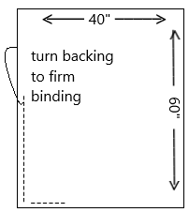
Lap Robe #1:
Fabric:
Cut 7” Squares washable cotton or flannel fabric. Make 7 rows with 6 squares each in each row. Flame resistant is best. You will need one piece at least 40” x 60” fabric for the back
1) Make 7 rows with 6 squares each in each row.
2) Piece together with ¼ to ½ inch seams. Be sure to sew
securely.
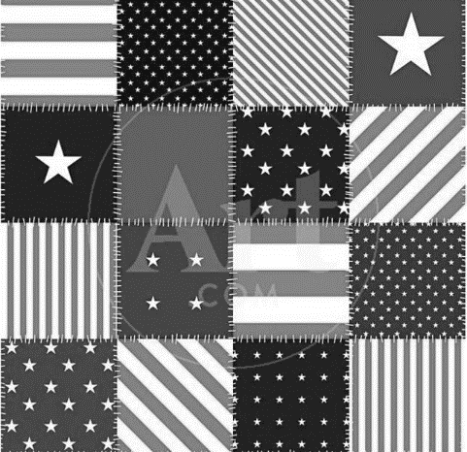
3) Add polyester lining
4) Bind with seam binding or turn the edge of backing to form binding.
5) Tie or quilt to finish
Finished Size:
40” x 60”

Lap Robe #2:

Sewn Lap Ropes: Size 3’ x 5’ made of all cotton washable material. Layer of flannel between 2 layers of cotton percale sheets or other cotton material.

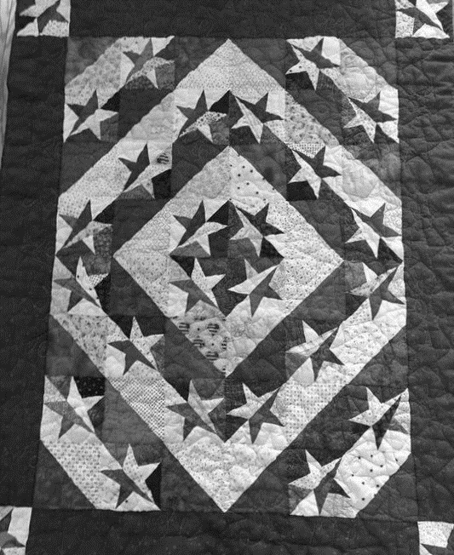
Twin Size Quilts:
Twin quilts are used at all Veteran’s homes by the residents as their personal bed cover. Twin and ¾ size are 70” x 90”. There are many wonderful patterns to make. The veterans especially like the patriotic ones. Wildlife and outdoor themes are also good.

Patriotic “End of Life quilt is used by residents in hospice care and remains with the resident or family until the end of their life. It is a touching tribute to their contribution and a way to say Thank you.

Page 2

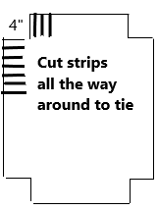
No Sew Fleece Blanket Pattern:
Fabric:
Two coordinating pieces of any fleece
- Baby or Toddler Blanket takes 1-1 ½ yards for each side
- Child takes 1 ¾ Yard for each side
- Teen or Adult takes 2 yards for each side
Hints:
- Fabric is usually 54” or greater.
- Double check that your two pieces of fabric are the same size
- Fleece panels look nice but be sure there is enough material at the edge to cut fringe without cutting into pattern
- Watch for sales at your fabric store, you can save more than 50%
Notions:
- Pair of good scissors or rotary cutter and mat
- Ruler or tape measure
Directions:
1) Cut off salvage edge on both sides, keeping you edges as straight as possible.
2) Lay fleece wrong sides together, with edges matching up. (Fleece sometimes
is hard to tell the right side from wrong side. **You may pin the layers
together.
3) Cut a 4x4 inch square (or 5x5 inch for longer fringe) out of each corner
through both layers of fleece.
4) Cut 4inch (or 5 inch) at 1inch intervals around all four sides. Tie overhand
knot close to blanket edge then tie again. Repeat around all four sides. Make
sure, you have two tight, overhand knots for your fringe
Special Notes:
1) Use a tape measure across the top of your 4“section to help you make the
cuts 1” apart but also only 4” Deep.
2) For a more even look, tie every other one all around the blanket, flip the
blanket and tie the rest.
3) Fleece is very stretchy, so be gentle when tying the edges (especially the
selvage) so fringe isn’t stretched out of shape.
No Sew Single Layer: Single layer lap robe can be made the same way.
Page 3

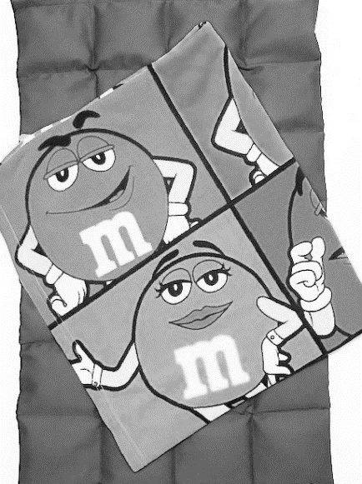
Weighted Lap Pads:

Plastic Pellets:
1). Using Plastic Pellets, fill 4” baggies (candy bags work well) with 1/3 Cup of pellets. Fold baggie closed and seal. Twenty-eight (28) filled baggies. Each weighing 3-4 oz. will make a 5-7 lb. lap pad.
(Victory Pellets ordered through Amazon (50#/$113.00) are machine washable and dryable. Made in USA!)
Fabric:
Use “Blue Trigger” fabric or similar 60” wide durable fabric. Cut 18 inches across salvage to salvage.
2) Sew up the sides (pillowcase style) and turn right side out
3) Make 4 columns by top stitching, even rows, parallel to side seams.
4) Insert a baggie (from Step 1) into each column.
5) Push tight, use straight pin to hold in place. Sew across the row containing the
1st of 7 rows of pellets.
6) Repeat 6 more times.
7) After final 7th row, fold over the salvage edge to create hem.
Weighted Lap Pad is complete.
Create a covering to enclose the Lap Pad:
Using soothing, washable fabric (Polar Fleece or flannel)
Option 1) Close by stitching a 6” piece of Hook/Loop fastener to edge of covering.”
Option 2) Cut fleece (or flannel) 18”, salvage to salvage, creating 18” x 60” piece. With right side facing up, fold over 9”- 10” ‘salvage’, then fold 25” from other edge. Stitch long 25” edges. Turn right side out to expose pocket created with 9”-10” first fold. No Hook/Loop needed with this option.

Note: Check with Facility before delivery, as some facilities are NOT using due to Weighted Lap Pad simulates as “restrictive measure”.

Page 4

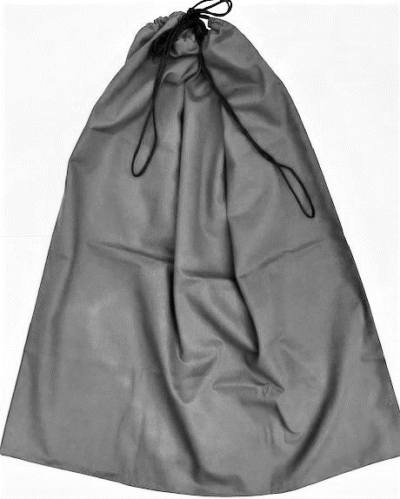
Draw String Laundry Bag:

Fabric:
The laundry bag is made from 1 yard of 45” sturdy fabric (trigger) with a draw string at the top.
Draw String:
Use paracord or cotton clothesline for the draw string.
Sewing Directions:
1) Fold fabric in half sewing the 36” side and across
the bottom. Seams should be
reenforced.
2) Sew a 1 ½” Hem on open edge to form casing for drawstrings. Insert
drawstring.
Finished Size:
The completed size will be approximately 25” x 36” when lying flat.
Note:
These bags are given to indigent and homeless Veterans for their use in transporting their personal belongings.
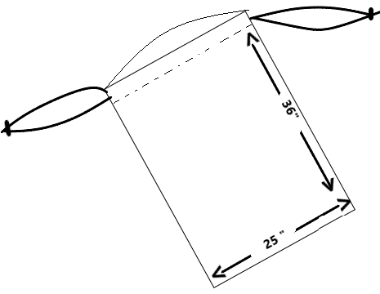

Page 5

Small Tote Bag:
(10” x 12” for personal items)

Fabric:
These bags can be made from the “trigger” fabric available from Department or use a colorful percale/calico. Material should be sturdy to with stand daily wear and tear.
Finished size is 12” x 10” with a draw string at the top. One tie from each side of bag makes it easier to carry. Ties should be long enough for a large hand. A pair of 32” shoelaces work well for the ties.

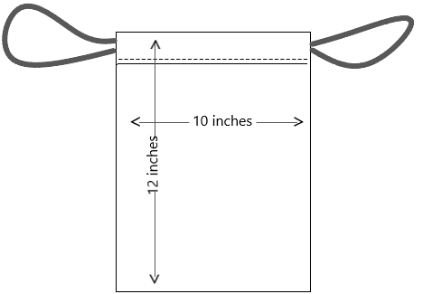

Page 6

Wheelchair Bag, for Back:

Fabric:
Cut fabric piece 36” x 22”. Sturdy fabric recommended.
Optional Lining; cut second piece of cotton or similar fabric.
Sewing Directions
1) Fold in half with right sides together (size now 18” x 21”) and stitch the two
Side edges leaving edge opposite fold open (If you want to add a lining,
repeat, and insert in bag.)
2) Hem open end with 1 inch hem and double stitch edges
3) Straps, cut piece of fabric 4 inches wide and 16 x 18 inches long. Fold like
bias tape. Stitch open edges together. Cut strip so that you have two pieces,
each about 8-9 inches long by 1 inch wide.
4) Fold each strap in half so you can position a strap on the inside seam of the
bag.
Stitch through all layers on each side to securely fasten straps.
(Example: stitch a square the size of your hem, then stitch an X in it.

Pocket (Optional):
If you would like to add a pocket on the front, cut a piece of fabric 8” x 18”. Hem top edge of pocket. With right sides together sew the bottom of pocket to the fold line of bag. Press and pin in place. Stitch a straight line through the pocket forming two compartments. Reenforce stitching. Then continue with sewing directions.
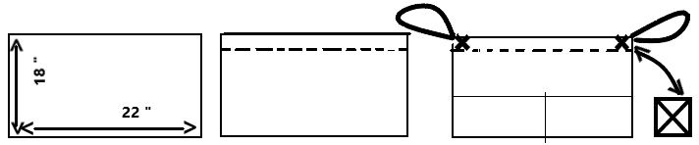

Page 7

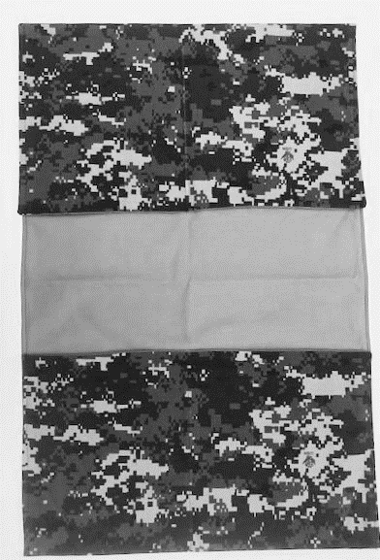
Walker Tote Bag
Fabric:
You need two pieces of fabric that are 14-15 inches wide by 43-53” long. Fabric can be identical or contrasting. Heavier fabrics are harder to work with but offer a finished product that is durable and able to hold heavier loads without sagging.
Notions:
- 6 inches of sew-on hook and loop tape (Velcro) cut in 3 Inch pieces
- Thread
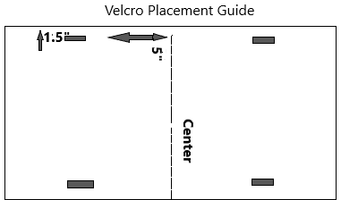
Sewing Directions:
Pin right sides together and sew all the way around, leaving a 6-inch opening large enough to turn tote right side out. Trim corners. Turn the tote right side out, press thoroughly so edges and seams lay flat. Use a chop stick or knitting needle to push the corners out so they are as square as possible.
Velcro Placement:
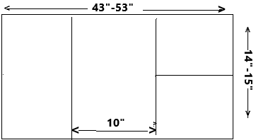
Mark the center of tote on the long edge by folding in half. The hook and Loop tape should be sewn five inches from center and 1 ½ inches from the side. See the diagram.
Edges and Pockets:

Fold up the ends of the fabric to make pockets on both sides. Measuring so that top of pocket is evenly placed from the center and covers the Velcro you stitched on. Approximately 5”. Pin pockets in place and top stitch around the tote close to edge closing the opening you left to turn tote right side out.
Sew a straight line up the center of one pocket to form two smaller pockets on one side. Be sure to reinforce stitching at top of pocket.
Page 8
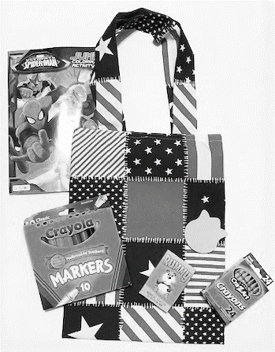
Child’s Activity Bag/Supplies:

Fabric:
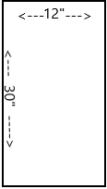
½ Yard of fabric or felt.
- Cut one piece that is 12 inches x 30 inches
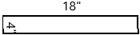
- Cut two pieces that each measure 4 inches x 18 inches.
Sewing Directions:
1) Fold 12 x 30 Inches in half (Measures 12” x 15”).
2) With right sides together stitch the side seams using ¼ inch seam allowance.
3) Turn right side out and press.
Strap Handles:
4) Sew the 4” x 18” with wrong sides together, turn right side out, press.
5) Place on end of strap handle at top of bag 2 inches from side seam and pin in
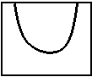
Place. Repeat for the other end of handle being careful not to twist the handle
6) Flip the bag over and match handles to the first side and sew in place.
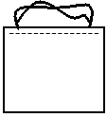
7) Zig Zag or stitch ¼ inch around top of bag.
8) Turn down ¾ inch around top of bag, press and top stitch to hold straps in place.

Children’s Activity Items that can be included:

- Small Mini Books
- Stickers
- Word Search Pages/Books for Children
- Dot to Dot Puzzles
- Foam shapes (Self-adhesive)
- Notebook or Paper

- Coloring Pages or Books
- Non-toxic Colors
- Lacing Cards
- Homemade Mini felt board w/Shapes
- Ziploc Bags

Page 9

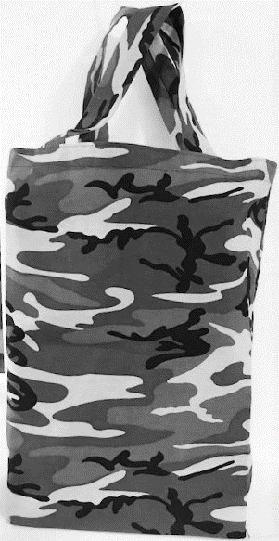
Large Tote Bag

Fabric:
You need 5/8ths of a yard. A stiff twill or trigger fabric is best.
Cut one piece 18 inches wide and the width of the fabric. The fold will be the bottom of the bag.
Sewing Directions:
With right sides together, sew a half inch seam on each side. Then you want to box the bottom of the bag so that it is 6 inches wide.
Straps:
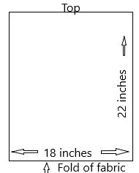
For straps you need 2 pieces that are 4 inches wide and 22 inches long. Fold these into 4ths and sew the longs ide of the fold to create your strap.
Top of Tote:
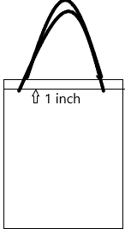
Fold the top of the bag under ¼ inch and sew around the top of the tote. Then turn the top of the bag down 1 inch. Place the handles over this 1inch seam. Place about 4 inches from each side seam. Sew around the top at the outer edge and at the inch folded down section so that you securely catch the handles.

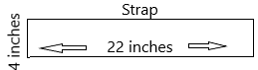

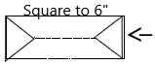

Tote Page 10

Family Bag:

These bags are provided to resident or Patient family members and supplied with personal products needed for extended stays

Fabric:
Use sturdy fabric, such as Trigger.
The finished size should be 16” x 16” with a 4” squared bottom. Create two handles or insert drawstring through the top hem.

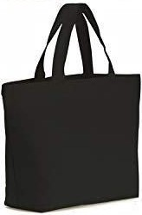
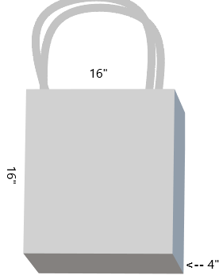

Page 11

Cover-Up with Ties (for Clothes Protection):

Fabric:
Terry cloth towel works well for this.
Directions:
1) Fold the bath towel in half lengthwise. Cut a 7inche circle about 4“ from the
edge of the towel to form opening for the neck. (a 7” plate makes a good pattern)
2) Use bias tape to finish the neck and opening.

Note: Do not add ties, snaps, or Velcro. These are generally draped over the shoulders and the loose ends gently tied.

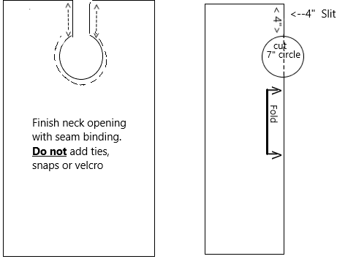

Page 12

Terry Cloth or Fabric Cover-Up/Shirt Protector:
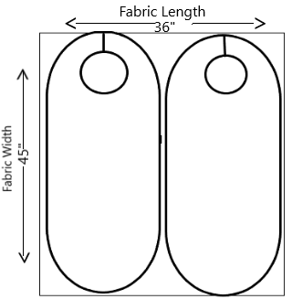
Double Layer
Fabric:
Terry cloth or other soft fabric a piece measuring 36” x 45” Cut 2 Pieces 18” wide by 39-40” long. Round corners. Cut out a 7” circle for the neck opening, with slit in the back.
Sewing Directions:
1) With right sides together, sew around leaving a 4”-5” opening to turn item right
side out.
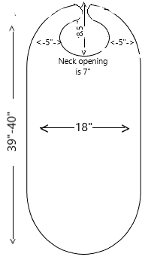
2) Turn right side out, trim, and press. Stitch opening closed by hand, or run a top
stitch around the outside edge.
3) Sew on a 1” piece of hook and loop tape (Velcro) on the neck opening as shown.

Single Layer:
This same pattern can be used for a single layer cover-up/shirt protector. Use bias tape to finish edges. This pattern works well with a 24” x44” terry towel. Round only the top/shoulders/neck. Finish with bias tape around neck/shoulders, using the original hem for the rest.

Note: Do not add ties, snaps, or Velcro. These are generally draped over the shoulders and the loose ends gently tied.

Page 13

Patient Shower Cover:

Note:
This cover is used to provide the patient/resident who is confined to his/her wheelchair some privacy when being transported from their rooms to the shower facility, and back to their room. It covers the upper body and around the wheelchair frame.
Fabric:
Fabric should be poly-cotton or regular cotton. Dark colors are better as they are not as transparent as lighter colors.
Directions:
1) The finished size is two (2) yards long and 25” wide. The edges are to
be finished by a rolled hem or serge and turn back once and stitch.
Round two corners on the long side where you will place the 9” by 15”
pieces from the next step.
2) Cut two pieces of fabric 9” x 15”. Sew one on each side as illustrated in
the diagrams. On this rectangle, stitch4” piece of hook and Loop tape
(Velcro) for fastening the cover together.
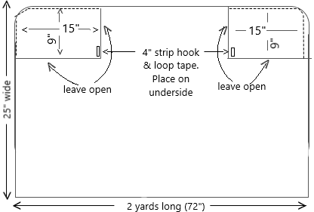

Page 14

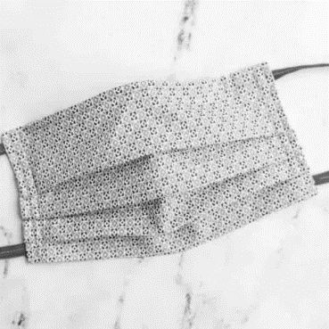
Pleated Face Mask:

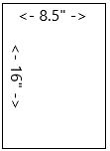
Fabric:
For adult size mask, cur 1 fabric rectangle 16inches long and 8 ½ inches wide. Cut 2 pieces of elastic, each 7 inches long.
Sewing Directions:
1) Fold fabric in half with right sides together. Sew along the 8 ½ inch width
edge using 5/8-inch seam allowance. Leave a 3-inch opening in the center of this
seam to create an opening to allow the mask to be turned right side out after
sewing. Press seam open.
2) Pin one piece of elastic to each side of the mask, one end to the top corner and
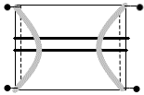
one end to the bottom corner sandwiching the elastic between the fabric.
3) Sew sides of the facemask, back stitching over ends of elastic to secure them.
4) Create three evenly spaced ½ inch pleats. Pin the folds in place, making sure all
pleats are facing the same direction. Sew down each side to secure the pleats.

Note: When mask is worn, the pleats should open downwards to prevent any particles from collecting in the fold pockets.

Note: Please check with your facility to make sure they can use the these masks

Page 15

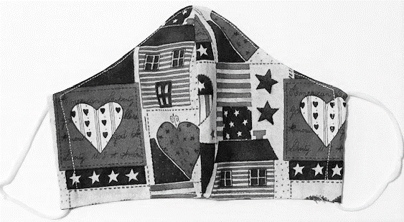
Face Mask Pattern:
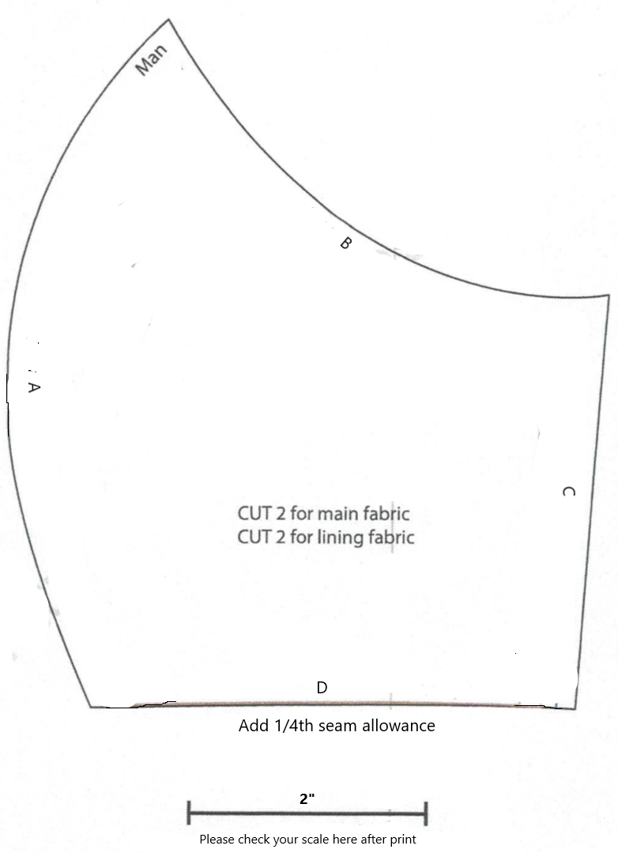
Fabric:
1) Prewash all material on hot and dry to preshrink fabric as much as possible.
2) Cut 2 pieces for the mask and 2 pieces for the lining. Please add ¼” to pattern for seam allowance.
3) With right sides together sew side A of mask and lining. Clip curve, press open.
4) With right sides of mask and lining together matching seams and edges, sew all around the mask leaving an opening on the bottom edge to turn mask right side out. Trim corners and curves so mask will lay flat.
5) Top stitch all around the mask ¼ “from edges closing the opening as you sew.
6) Fold the two sides in ½” and stitch forming a casing.
7) Insert 9” piece of thin elastic. Tie a knot and ease knot into casing to complete.

Note: Please check with your facility to make sure they can use the these masks.

Page 16

Urine Bag Covers:

Fabric:
Fabric for these bags should be washable and white in color. Fabric such as broadcloth or muslin can be used. Cut fabric at least 14” to 15” square and allow a ½” seam allowance. Allow for hem on tote design.
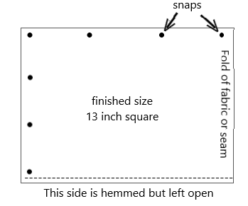

Cover with Snaps:
This cover has a finished size of a 13-inch square. It is fastened on two sides by snaps for easy access in covering and removing for laundry. The third side is a fold or could be a seam. The fourth side is left open.

Tote Style Cover:
This cover uses a 13-inch tote bag with ties that are at least 6 inches wider than the square bag. 36-inch shoelaces are a suggestion for ties or a white twill tape.

Note: Please be sure to check with the facility to see if they use these or which style they prefer.
Page 17

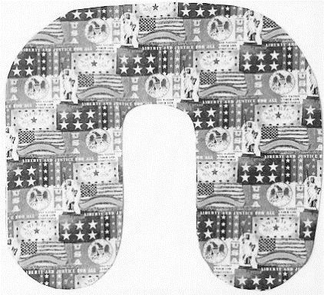
Neck Pillow (Small):
Fabric:
½ yard of fabric plus ½ yard for contrasting or 2 pieces 18 x 20 inches. Choose a soft fabric such as flannel or cotton. Bright or patriotic colors are cheerful.
Sewing Directions:
1) With right sides together sew pieces together leaving a 5” opening at the top.
2) Clip inside curve around neck being careful not to clip your stitching.
3) Stitch inside curve around the neck again to reinforce.
4) Turn right side out and press.
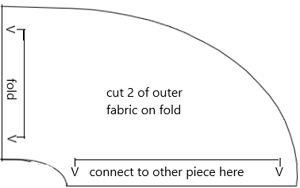
5) Stuff with polyester fiberfill till very firm. Hand stitch close.
Page 18
Neck Pillow(continued)
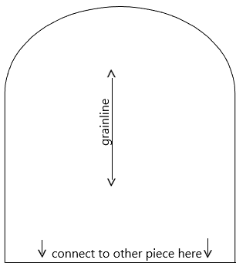
(Add 3-6 inches here to make longer neck pillow) Page 19

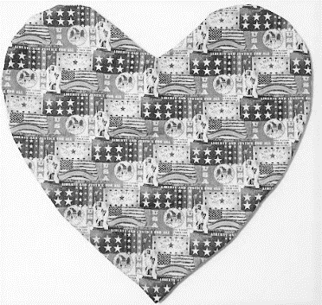
Heart Pillow:
Fabric and Notions:
You need ¾ Yard for each side. Matching or contrasting. (Total 1 ½ Yards)
Polyester fiberfill. Use ¼ inch seams. Finished size is approximately 18” x 18”.
1) Attach pattern pieces together. Arrows will not match up.
2) Cut 1 from main fabric and one from contrasting fabric. (Cut 2 total)
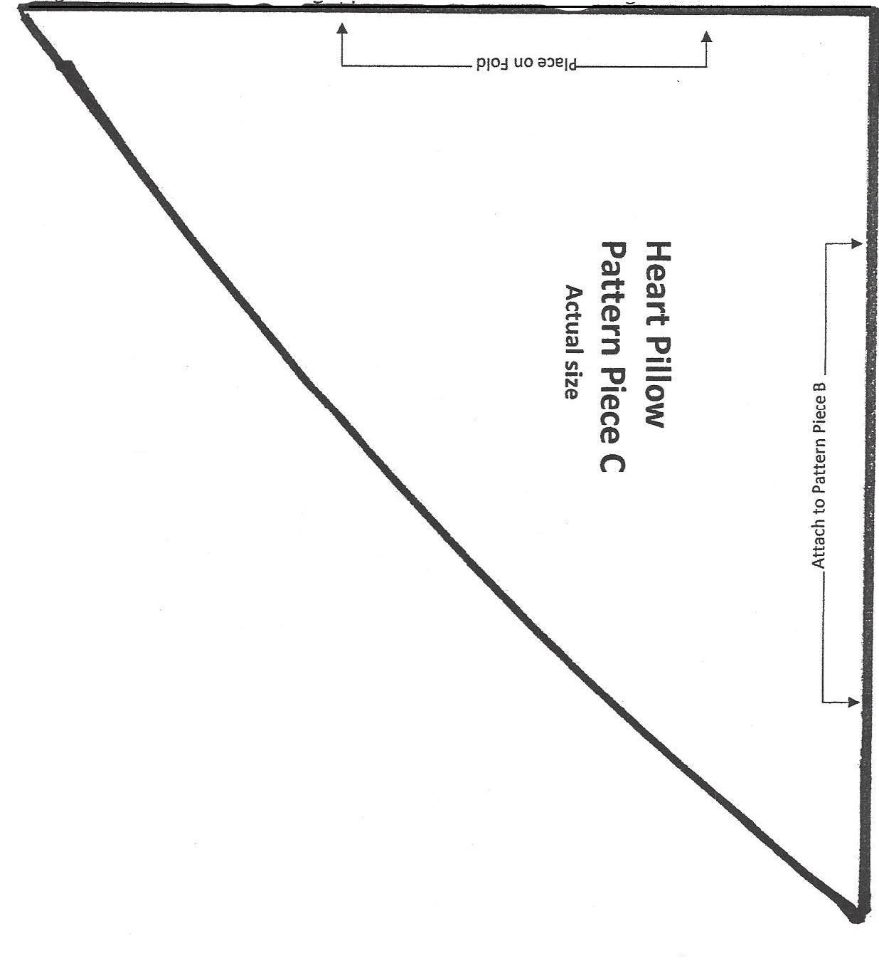
3) With right sides together stitch around heart leaving a 3–4-inch opening on one side.
4) Trim and clip curves
5) Turn right side out and press.
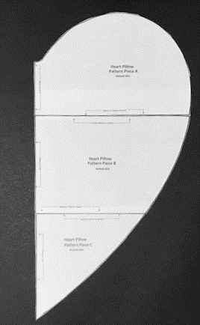
6) Stuff with polyester fiberfill till firm.
7) Hand stitch closed.

Note: Fill with 12 oz bag of polyester fill.
Page 20

Heart Pillow (continued):
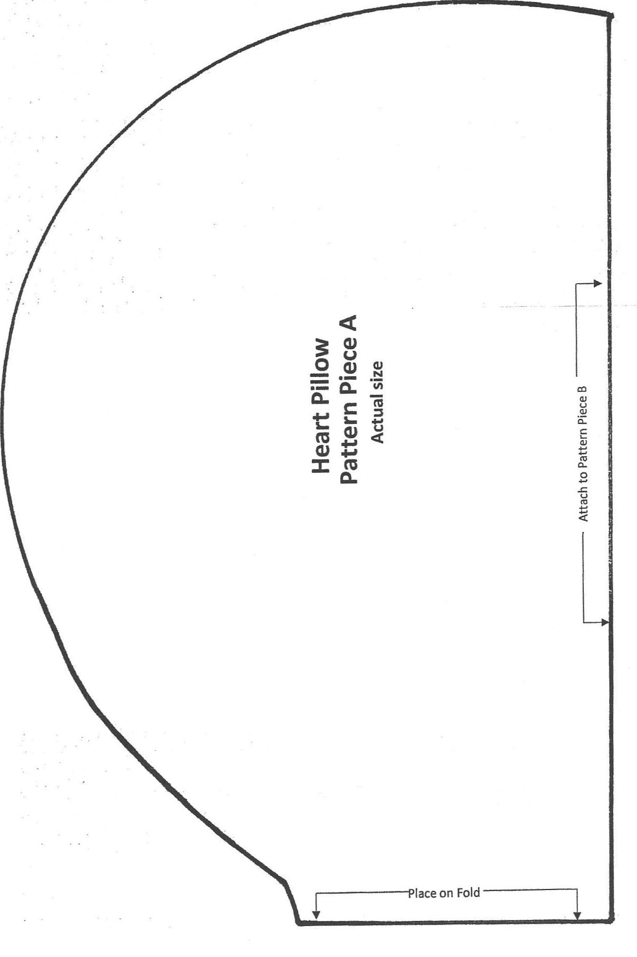
Page 21

Heart Pillow (continued):
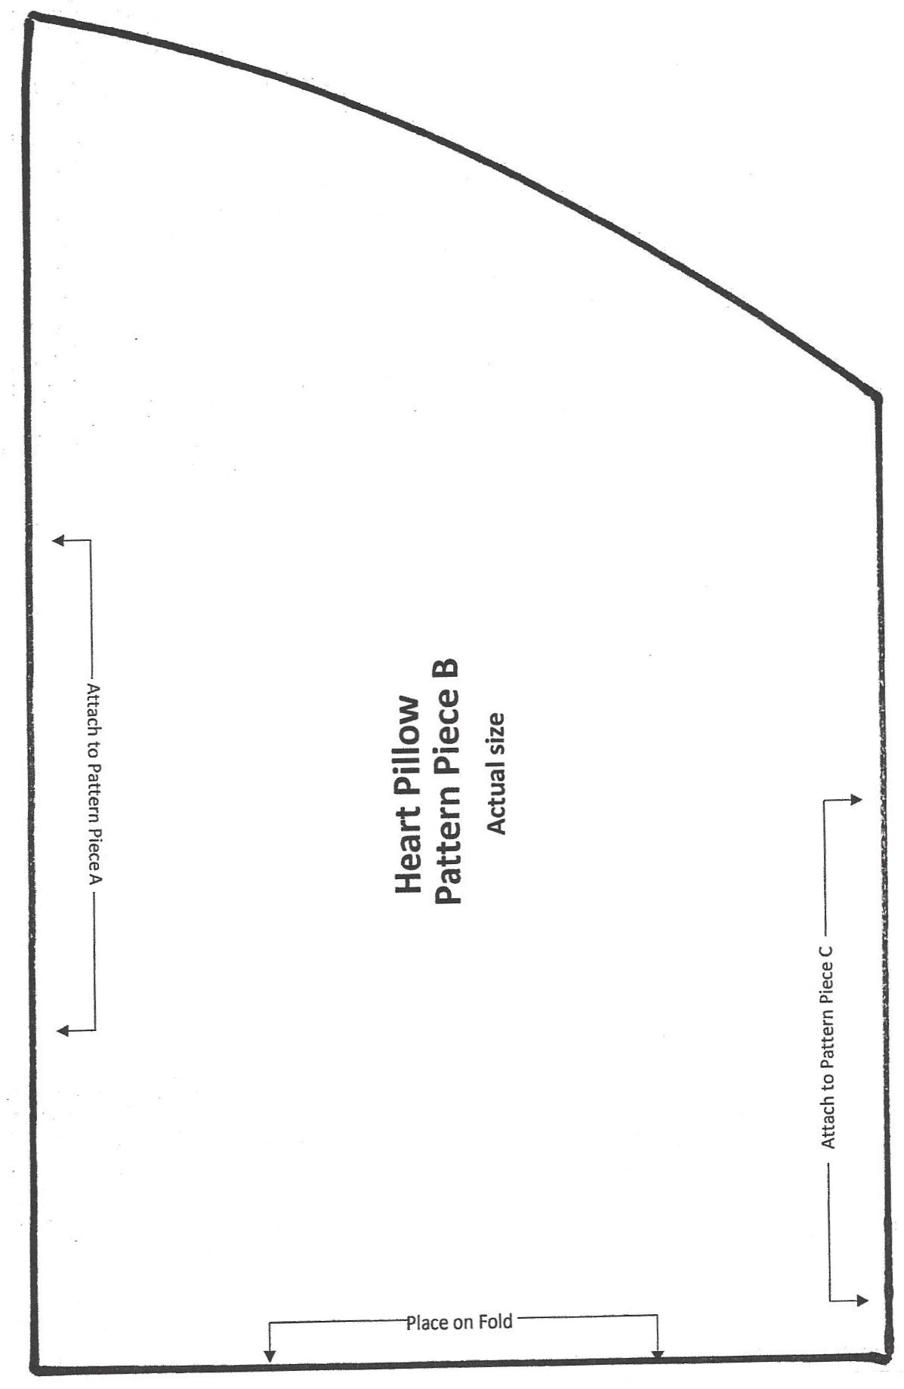
Page 22

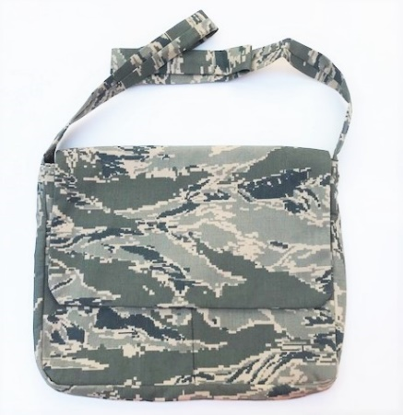
Cross Body Messenger Bag
10 x 12 Cross Body Messenger Bag with Velcro flap and front pockets

Fabric:
Front and Back body & Lining: cut 4 - 11” x 13” (round bottom corners)
Flap: cut 2 – 9” x 13”
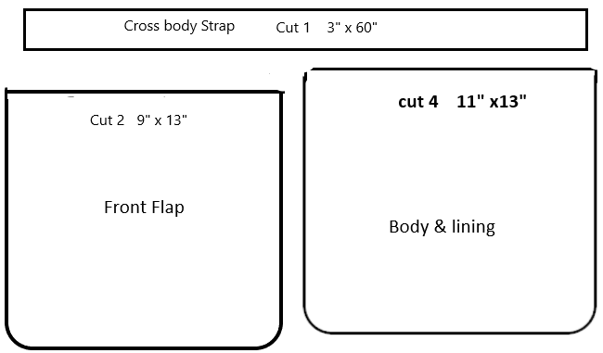
Gusset: cut 2 – 2” x 34” (one main fabric & one for lining)
Pocket/Lining: cut 2 – 8” x 13” (round bottom corners)
Strap: cut 1 – 3” x 60” (or longer)
Lining: Front and Back: cut 2 - 11” x 13” (round bottom corners)
Notions:
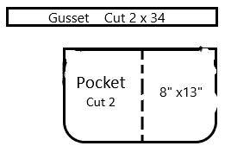
- 2” piece hook & loop tape (Velcro)
- Thread
Sewing Directions:
1). With right sides together, sew top edge of pocket
pieces. Turn and press. Mark center and stitch from
top to bottom forming two pockets. On the pocket,
about 2” from top of pocket, center a 2” piece of
Velcro. Pin pocket to front piece of messenger bag.
2). Sew the front of bag to gusset easing fabric around edges. Sew back piece of
bag to the gusset. Do the same with lining pieces.
3). On piece that will be inside of flap, center and sew the Velcro piece about 2”
from the edge with rounded corners. With right sides together sew flap pieces
together, trim, turn and press.
4). With right sides together, sew edges of crossbody strap together, turn and
press. Attach the strap to the gusset securely. Make sure strap is not twisted.
5). Sew the Flap piece to the back of the bag.
6). With rights sides together place the bag section inside the lining of bag. Sew
the edges together starting edge of the gusset across front of bag leaving the
edge with the flap open. Turn and press.
7). Along the flap/body edge, turn in seam and top stitch to close.
Page 23

